2-methylpentanenitrile
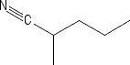
Main Function Group: Secondary Nitrile
- Common Name – 2-methylpentanenitrile
- IUPAC Name – 2-methylpentanenitrile
- Molecular Weight – 97.16 g/mol
- Melting Point – N/A
- Boiling Point – N/A

